This post was originally published on www.okinawahai.com on 3/6/2009
Editor's Note: This is the original Okinawa Hai post on Cape Hedo. We published a newer post on this landmark in 2016. We've left all of your original comments in place on this post, but we thought after 6 years you might want a fresher take on the place.

CONTRIBUTED BY DASHA GARIEPY

Today's adventure takes us to Cape Hedo!

Now, I know many of you have already been to Cape Hedo. In fact, we've joked that the only difference in our photos is the kids standing in front of the statues! (That sentence is grammatically correct, by the way, the "is" goes with the word "difference" not "photos" ... I know you were questioning it!)

The point being, photos from Cape Hedo are all strikingly similar, from the Jurassic-like view in the picture above, to the crashing surf in the picture below, down to the odd assortment of monuments and statues, my favorite being "Super-chicken"...

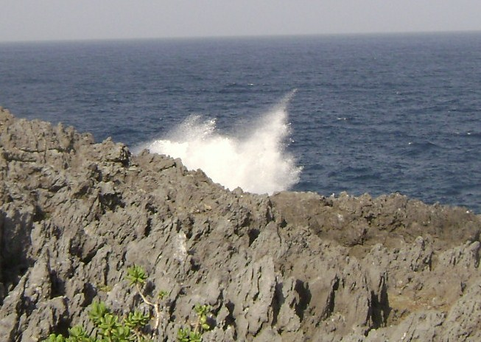
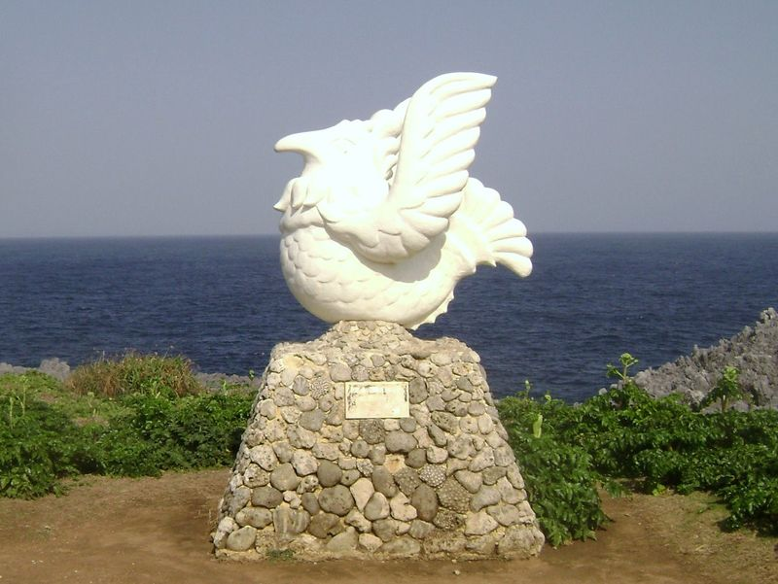

Cape Hedo is an explosion of contrasting colors: emerald greens, azure blues, marble whites. (We went on a hazy day, so my pictures do not do the beauty of the place justice.)

The cliffs are riddled with walking paths. The paths are riddled with monuments. The monuments are riddled with these little coin collection thingies. Someone told me they are shrines for sailors lost at sea, toss in a coin and say a prayer for the dearly departed. I googled a variety of options but couldn't find anything related to these boxes. I did learn that there were over nine thousand military men lost at sea here during WWII, which would explain why these little shrines (if shrines they are) are on most of the beaches I've been to. Does anyone have the real scoop on these things?

Getting back to Cape Hedo, though, it's a great way to spend the day. Take 58 North, and keep going, going, going. It's the Northern Most Tip of the island, and well marked; you can't miss it. We opted to do the entire loop of the island, so instead of coming home via 58, we headed around and down the other side on 70. It was fantastically scenic. There are many dams to explore, several very picturesque seaside villages (looking more like Cape Cod than Okinawa!), and terrific sweeping mountain views. We drove around for about eight total hours, stopping periodically to take pictures. We did happen quite by accident on Hiro's Coffee Farm, and had an very tasty cup of joe. All in all it was a great day, an adventure I'd suggest you take soon, if you haven't already.

By the way, if anyone has a picture of the godzilla-sized roadrunner-type bird sculpture that's perched on one of the hill tops across from Cape Hedo, I'd love a copy. I'd also like to know what in the heck that thing's all about!

